Year 7
HOMEWORK 1 – Using the bar model to draw diagrams and write maths sentences
Answer all questions to the best of your ability. Don’t forget to come to Maths Clinic (Monday, Tuesday, Thursday & Friday in IT04 from 12:30-13:00) if you need some help!
Please answer questions on the sheet. Do not use your calculator unless specified.
Make sure you show your working!

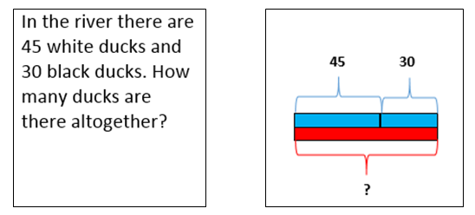
Example

Write a maths sentence to represent this situation: 45 + 30 = €
Question 1
In a school there are 100 teachers and 800 pupils. How many people are there in the school altogether?
- Draw a bar model to illustrate this problem.

- Write three maths sentences to represent this problem.

Question 2
- Write a story for these bar models.
?
14
8


4
8
?
40
Question 3
- Write 3 maths sentences for this diagram.
23
5
12
a

- What is the value of a? Show how you work it out.


Initials: ______ Date: _________
WWW  What went well | € You can draw a bar model when given a written problem  € You can use your bar model to write maths sentences  € You can use bar models to help you find unknown values
NYM  Now you must | Revise: drawing bar models with simple problems (e.g. Petra has £8 and Zak has £6. How much money do they have altogether?)  Try: highlighting the numbers or letters used to represent values in the problem  Try: drawing the rectangles of your bar model and colouring in the one which is the unknown value  Make sure that you: check your working / show your working out / include any units  Use: MyMaths.co.uk or come to Maths Clinic (Mon, Tues, Thurs & Fri lunchtime – IT04).  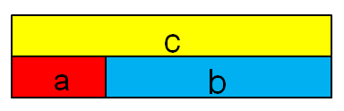  Please complete:  - If b = 2.5, what could be the values of a and c? Give five examples.
AT
Action taken

Mark Scheme
Print homeworks in this format. Use one A4 sheet per homework:
Assessment sticker page, which when folded will form front of booklet
Blank page for sticking into book
Homework page 1
Homework page 2
and on the reverse

Question 1
100
800
100 + 800 = 900
900 – 100 = 800
900 – 800 = 100
900
Question 2
- Any story is acceptable in which 8 and 4 sum to 12
- Any story is acceptable in which 8, 14 and 18 sum to 40
Question 3
- Any maths sentences in which
a + 12 + 5 = 23

- 23 – (12 + 5) = a or 23 – 12 – 5 = a a = 6
Challenge question (from assessment sticker)
Any values are acceptable where
a + 2.5 = c
or
c – 2.5 = a

