
Buying skirting board

- Ellie also calls at the DIY store. She has a builder coming to put new skirting board and beading in her bedroom. She chooses the ‘ogee’ style of skirting board shown in the picture:
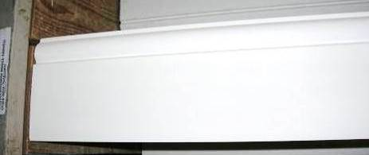
Ogee skirting
18 x 119 x 3600 MM
£16.80

The ticket details for this skirting board are shown in the box above.

- Which parts of the skirting board do the measurements refer to?

- The distance around the walls of Ellie’s bedroom is 20 m. Ellie cannot decide whether to do her calculations in metres, centimetres or millimetres.
She starts her ratio table like this:
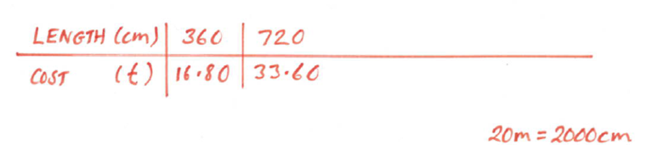

Use this ratio table (or one of your own) to work out how much it will cost Ellie to buy enough skirting board to go around her bedroom walls.

- Ellie chooses the beading shown below. She decides to bead only the two outside walls of the room, as these are the draughtiest. This is a distance of 10.8 m.
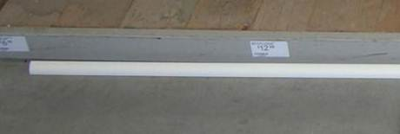
MDF painted beading
2400 x 18 x 18 MM
£4.00

Use a ratio table to work out how much it will cost Ellie to buy enough beading to cover the two outside walls.

