ACTIVITY 1
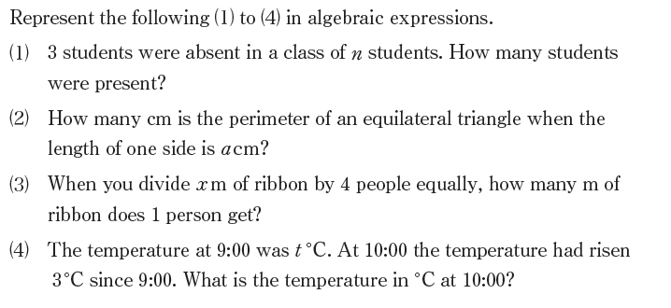
EXTENSION
Of the letters used in the algebraic expressions above, which ones:

Can only represent integers?

Which ones can represents numbers including decimals?

Which ones represent numbers including negative numbers?

ACTIVITY 2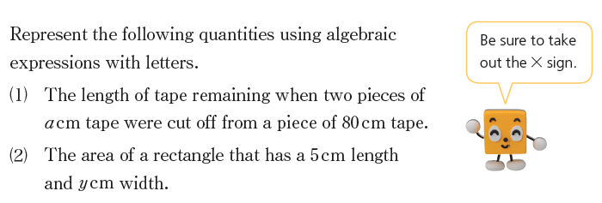

ACTIVITY 3

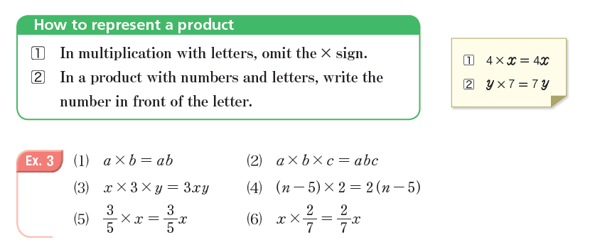
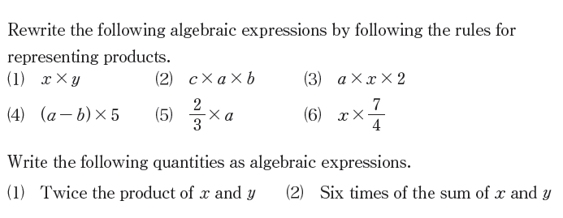

ACTIVITY 4
