Buying in Bulk

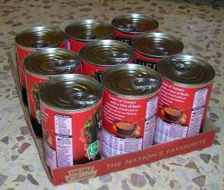
Tins of soup come in trays of 9.

Craig starts a ratio table as follows:

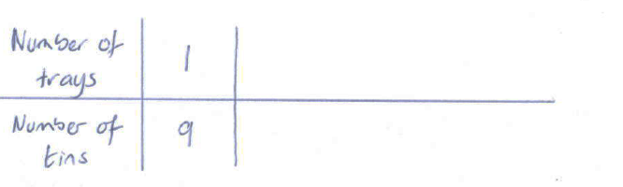

- What else do you know? Copy the table and fill in some other values.

- Find the number of tins in 35 trays.


Ice-lollies come in boxes of 15.

- Use a ratio table to find the number of bars in 18 boxes.

- Compare your ratio table with other students. Is there only one way of finding a correct solution?

Packs of chewing gum come in boxes of 48.

Use a ratio table to work out how many packs there are in 23 boxes.


At the wholesalers

Every fortnight Craig goes to the wholesalers to restock on the supplies he is short of. Craig needs to restock on his supply of chocolate bars. He looks at the brands available to see which is the best buy.

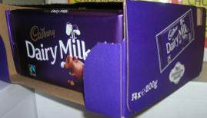
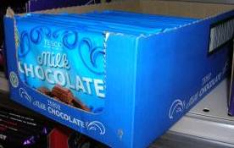

A box of 14 bars costs £8.40 A box of 20 bars costs £14.50

Craig draws two ratio tables and wonders how he can compare the prices

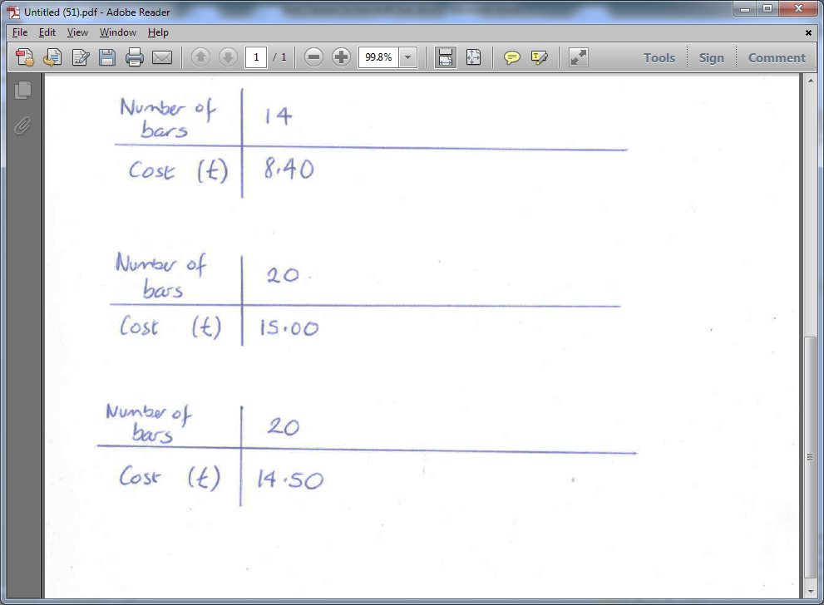

- Copy the ratio tables and fill in some other quantities that you know the cost of.
- Can you figure out which brand is cheaper? How did you do it?

Craig is wondering which brand of batteries to go for.
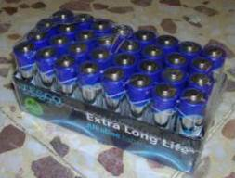
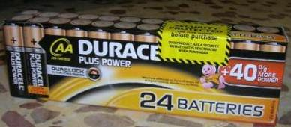

A box of 24 costs batteries costs £14.40 A box of 32 batteries costs £16.60

- Make two ratio tables and fill in some other quantities of batteries that you know the cost of.

- Which brand is cheaper?

The wholesale prices for two brands of butter are as follows:
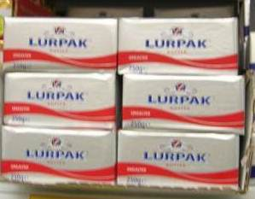
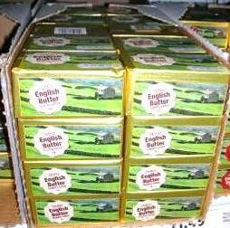

A box of 40 packs costs £48.00 A box of 36 costs £45.00
- Make two ratio tables and fill in some other quantities of batteries that you know the cost of.

- Which brand is cheaper?

The wholesale price for two multipack of crisps are as follows:

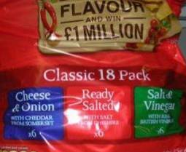
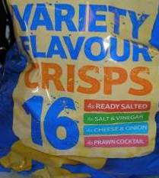

Blue brand : 16 packs cost £2.40 Red brand: 18 packs cost £2.70

- Make two ratio tables and fill in some other quantities of batteries that you know the cost of.

- Which brand is cheaper?

