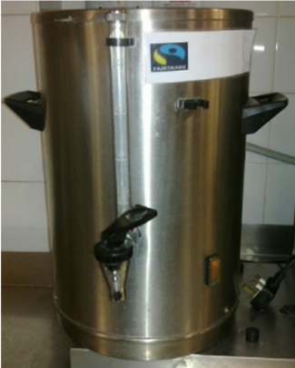
When it is full, the urn can supply 120 cups.
The pictures show the gauge at various stages of the day
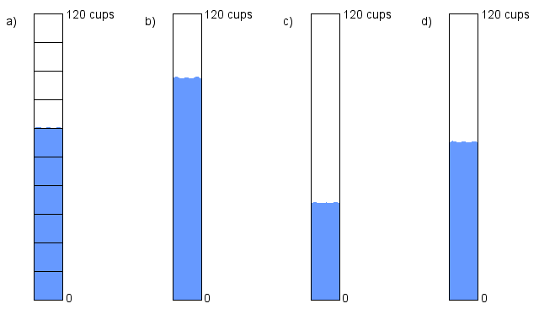

- For each picture, estimate what fraction of the urn is full.
- For each picture, say how many cups of water there are left in the urn.

When it is full, the urn can supply 120 cups.
The pictures show the gauge at various stages of the day

- For each picture, estimate what fraction of the urn is full.
- For each picture, say how many cups of water there are left in the urn.

