
Ribbons

Here are three more samples of ribbon:
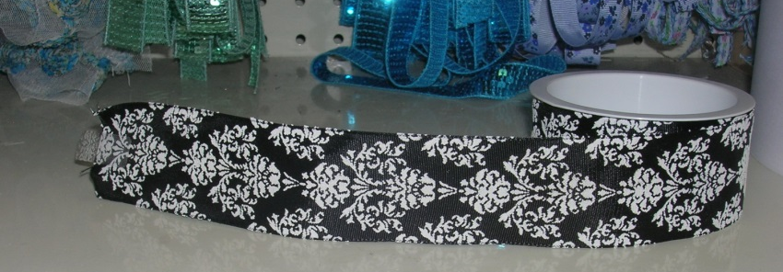
Sample A
40 cm of this ribbon cost 92p

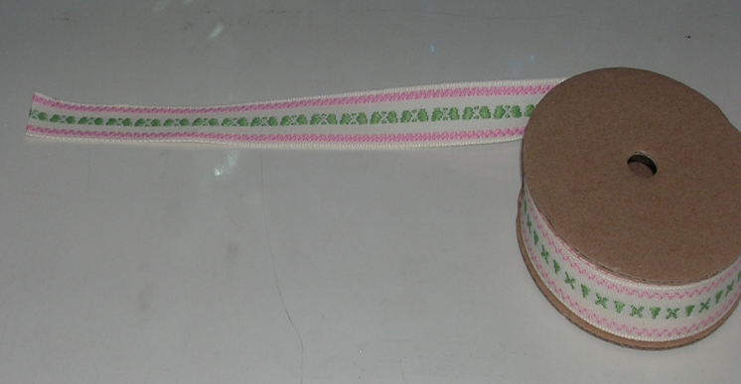
Sample B
60 cm of this ribbon cost £ 1.32

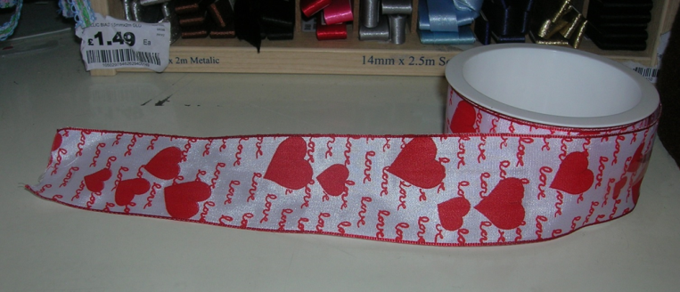
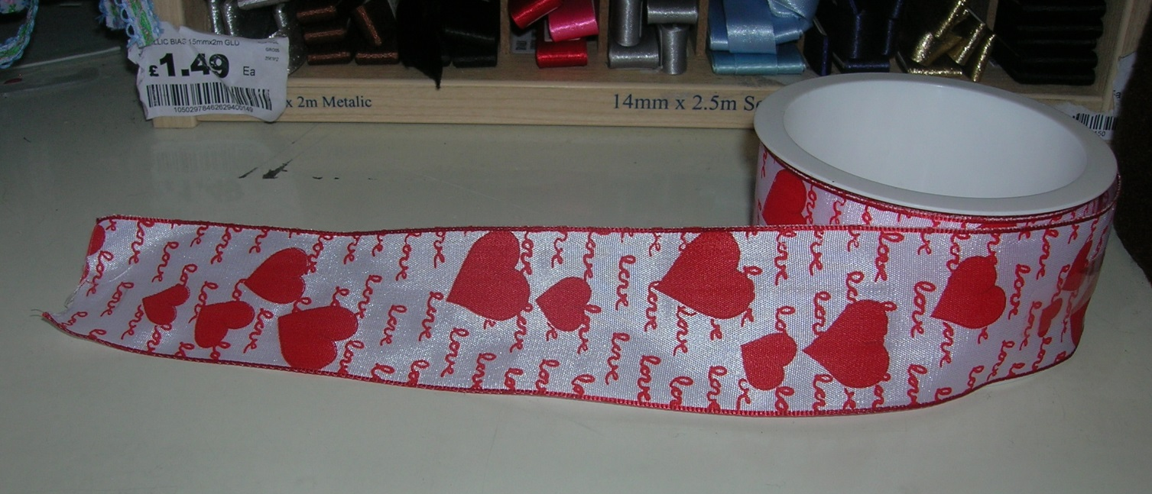
Sample C
75 cm of this ribbon cost £ 1.80

- Draw a bar to represent each sample of ribbon

- What else do you know about each ribbon? Use you bars to fill in some other quantities that you know the price of.

- Which of these three styles of ribbon would work out to be the most expensive?

