Year 8 Autumn 1 Lesson 7 : Sales prices
Objective | To calculate a percentage decrease using a bar model.
Aim | Students develop their use of the bar to include finding other percentage amounts, by combining the landmark percentages where appropriate. They are required to reduce prices by a certain percentage, on the bar; this involves working backwards from 100% once they have found the value of the reduction.  The use of multiplier to find percentage increase and decrease will come in a future lesson – for now the objective is to use the bar to solve the problems.
Resources | Powerpoint  Print off of slides 4,5, 6 and 8 if required.

Activity 1:
Dad wants to buy a laptop for his son for Christmas. He uses the internet to compare the price in various stores. In PC Express the laptop is priced at £479, whereas LAP Gear are offering the same laptop for £520 with a 12.5% reduction.
Students copy the bar onto their mini whiteboards to see if they can find the price.
There are various ways to complete the bar. It is worth encouraging students to demonstrate and explain their strategies to the rest of the class. Some students fill in 25%, then 12.5% then go back from 100% to 87.5%. Another strategy is to find 10%, then halve and halve again to find 2.5% and combine these to get 12.5% … and so on.
The reduced price at LAP gear is £455, which is cheaper.

Little progress | They say they don’t know how to find 12.5%
Questions for progression | - Which percentages do you know how to find?  - What percentage is represented by the line in the middle? What price does that correspond to?
Some progress | They can fnd 50% and 25% but can’t make the connection to 12.5%
Questions for progression | - How did you find the percentages you have so far?  - What would you get if you continued to do that?
Substantial progress | They complete the question and find that at £455, LAP gear laptop is better value.
Questions for progression | - Can you find your answer in a different way?  - What is the most efficient way to find the answer?

Bring class together to discuss how the bar was broken down to find the answer

Activity 2:
Individual work.

Students draw bars on their whiteboards to find the answers.

Students should be encouraged to draw their bars free hand, this is meant to be a free thinking tool where students fill in quantities according to what they see, rather than using a ‘standard procedure’ to fill in each bar. Some possible bars for parts a are shown here:
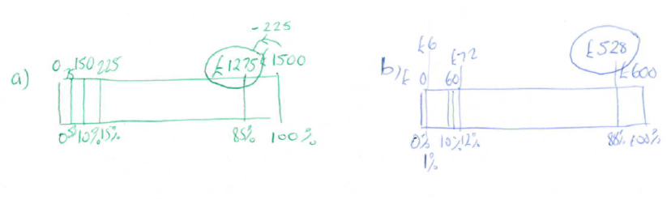

They shouldn’t rub off the answers in between. When they are happy with all four, they should draw two of them in their books as examples, explaining their reasoning.
Answers: holiday price is now £1150, Car price now £1975
Little progress | They draw the diagram, and label the ends correctly. They find halfway and 25% but struggle to turn that into 15%.
Questions for progression | - Rather than splitting in half, what is another easy number to divide by? (10)  - How does that help?  - What other percentage can you find now?
Some progress | They split up into amounts, but don’t take the percentage off 100%
Questions for progression | - If it has been reduced by 15%, how would you show this on the bar?
Substantial progress | Answer all the questions correctly:
Questions for progression | - Move onto the sale prices challenge. Which is the best website to buy the scooter from?  - Can they represent all their findings using a bar model?  Answers:  In Scooter World the price is £114; In Scooters and Bikes the price is £112.50; In Scooter Zone the price is £110, so Scooter Zone is the cheapest.  - Is this the best deal for every starting price?  - How do you know?

Students should be brought back together at this stage to go over and check answers, making corrections where required.

Activity 3: Finding errors
Show the students the question:
In a sale, a television has 25% off. The sale price is £600.
What was the price before the sale?

They should look at it in their pairs for a couple of minutes.
Bring the class back together and show them an incorrect answer and ask them in their pairs to come up with an explanation using the bar model to show why the answer is incorrect.

Ask students who have good explanations to share their answers.

This is to address a common misconception.
Questions for progression | - How would you represent this problem on a bar?  - Where would 100%$ be on the bar?

Activity 4: Working backwards

Students work in their pairs to find the missing numbers on the last slide.
These are quite difficult, and some students will struggle, but it is good for them to try for a while before going over any solutions.
Questions for progression | - How would you represent this problem on a bar?  - Where would 100% be on the bar?  - What would be a good way to split the bar up?  - Why?  - How much is this part of the bar worth?

Acknowledgements:
NCETM multiplicative reasoning materials

