Year 8 Term 1 Lesson 4 Ribbons
Objective | To be able to draw a bar to represent a particular context where quantities are proportional, accurately placing other information that they know to be true, on their bar.
Aim | In this lesson students work with a variety of contexts where the bar model emerges as an appropriate representation of the context.  The contexts used include blocks of cheese, butter, a hot water urn and ribbon. Most of which can be modelled as a rectangular bar.  Students develop ways of working with the bar to help them solve a variety of problems where the quantities are directly proportional
Resources | Powerpoint  Cheese worksheet – put this in plastic wallets for students to write over to save on photocopying.  Urn worksheet  Ribbons Worksheet  Summary questions

Activity 1: Catering
Students individually make decisions about where to cut the food.

They should share their strategies, which may well vary.

Some students have a tendency always to imagine cutting in half and working from there. Other students develop a ‘fitting in’ type approach. i.e for part b) some students will recognise that you can fit 5 lots of 50 grams into 250 grams, hence the need to split the butter into 5 equal parts and cut off one of these. Others may imagine the halfway point as 125g and put a marker slightly left of that to indicate 100g.

The Brie answers are potentially interesting, some students may try to continue with vertical cuts rather than going for uniform slices cut along the radii of a circle. Cutting 100 grams from 900 grams can be done in various ways. Some students may recognise the value of cutting into thirds first.

Questions for the class | It is worth discussing this context;  - Have you had any experience of gathering ingredients for a recipe, how do you do it?  - Do you think it is ok to estimate as Ruby does?  - Is there any guidance on food packaging, which helps you to estimate rather than having to weigh precisely? (Some students may be aware of the markings on the inside of a butter packet, or the outside of a tin of beans for example)

Activity 2: Urn

Again, some discussion of the context can prove fruitful. Have they ever seen one of these urns? Perhaps they are used on parent’s evenings or at school concerts? Why might it be important to be able to keep a track on how full the urn is?

Students could be asked to answer the first two individually and then to describe their strategy to the person next to them.

Again, strategies will vary. Some students can immediately say that for part a) one of the divisions must be equivalent to 12 cups. Weaker students who are not secure about this may need to use a ‘figuring out’ approach. i.e they know half way is 60 cups and may need to use guess and check on each portion to see what amount leads to 60 at the half way point.

Some students use the divisions of part a) to estimate the other parts. Other students may try a ‘fitting in’ type approach. i.e for part c) if they chunk up in pieces the same size as the bottom piece, they will realise that 3 chunks takes them just above the 120 cups mark. Other students use halves and quarters as reference points. Some students might like to make a strip copy of the bar and try folding in order to look for relationships between the part and the whole.

Answers should be in the region of: a) (i) 6/10 ths (ii) 72 cups b) (i) 3/4 (ii) 90 cups c) (i) 1/3 (ii) 42 cups d) (i) 54/100ths (ii) 64 cups, but will vary depending on the strategy used.

Questions for progression | - How did you work out your answer?  - Can you find a different way to find the answer  - Why is their answer different to yours?

Activity 3: Ribbons

Students to answer the green dotty ribbon question on their whiteboards.

Some may make a copy of the picture on the board and put a £1.16 price tag on it. Others may draw a rectangle to represent the ribbon and put a price tag on it.

It is also important in the early stages to insist that additions to the bars are placed in the ‘correct’ place taking account of scale. The questions provide students opportunities to practice drawing bars and to develop the freedom to fill in what else they know. Some students can get fixed on doubling (i.e drawing the bar twice as long) and halving and may need prompts to attempt partitioning the bar into say three equal parts. The quantities used were deliberately chosen to force a need to partition each half of the 6-metre bar into three parts.

We want to encourage students to get to eventually get this diagram:

One of the drawings which has the most potential to help students answer is shown below.
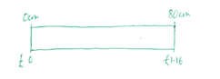

After the class discussion for the first two ribbons, students should complete the worksheet individually.

Questions for progression | Once this image is shared you can ask questions like:  - What other quantities of this ribbon would you know the price of?  - Label them on the bar.  - How do you know you have put this in the correct place?  - Who can show us where 1 metre of ribbon would be on this picture?  - How much would that cost?

Activity 4: Summary questions
Students individually work on the summary questions.

Some students will naturally begin to draw in order to answer the summary questions.

Some faster graspers may already be capable of answering problems in proportional reasoning. For them, this lesson is as much about developing use of the bar model and a recognition that drawing something can be a useful strategy for approaching a range of problems. Where students offer alternative strategies to the bar, it is important to ask them to describe where they can see their own method on the bar. This can help students to make sense of the rationale behind their strategy.

Some students may be able to answer the questions correctly without drawing. It may be worth getting the students to attempt these questions individually and then compare their strategies

Here are some solutions to the summary questions which make use of the bar model:

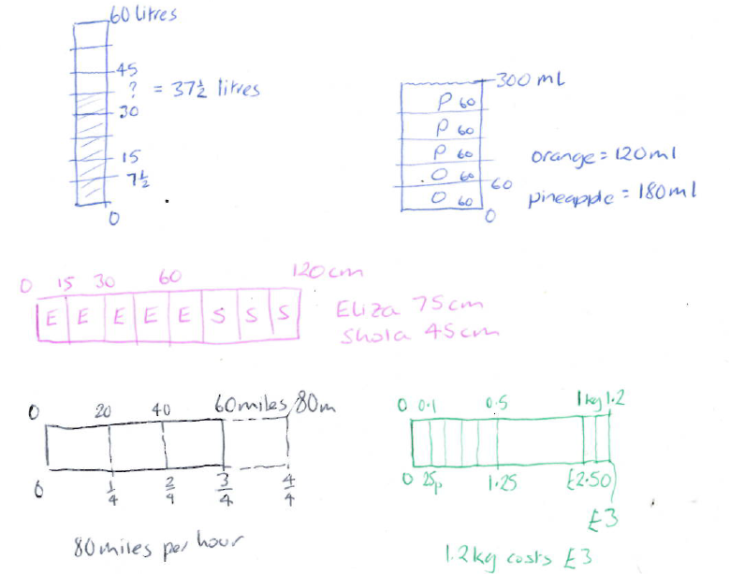

In the last two questions, the contexts do not necessarily conjure up the image of a bar. Here we see the possibility for applying the bar model to a wide variety of maths problems.

Questions for the class | - Can you see your method, which did not involve drawing, within the bar?  (I.e If a student answers question 1 using a routine like ‘I divided by 8 and times by 5’, then yo ucould ask the students to consider: ‘Which part of the bar refers to divided by 8, and which part refers to the times by5?)

Acknowledgements:

NCETM Multiplicative reasoning project

