
Year 8
Progress Check
Spring 1
Year 7

Mathematics


First name
Last name
Teacher

Instructions
You may use a calculator to answer the questions in this test.

Questions and answers
- You have 1 hour to complete this test.
- Follow the instructions for each question.
- If you need to do working out, you can use the space around the question.
- You may get marks for showing your method.
- If you cannot do one of the questions, go on to the next one.
- You can come back to it later, if you have time.
- If you finish before the end, go back and check your work.

Marks
There are no marks for the questions – you are being tested so that we your teacher can identify the areas you may need extra practice on.

Test Analysis

How to use this sheet
Colour the boxes for each question.

You will clearly see which areas you have done well in, and which areas need more work.

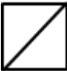

Indices | 1 |  | 7 |  | 13
Brackets | 2 |  | 8 |  | 14
Equations | 3 |  | 9 |  | 15
Inequalities | 4 |  | 10 |  | 16
Circumference | 5 |  | 11 |  | 17
Area | 6 |  | 12 |  | 18

Which areas do you need to improve?

(a) Simplify a²⁰ × a⁵
1

(b) Simplify

(c) Simplify (a²⁰)⁵

(a) Expand 4 ( x + 2 )
2

(b) Expand x ( x – 6 )

3
Find the values of x:
(a) 5x – 3 = 12

(b) 13 + 2x = 3

(a) If x ≤ 0,
4
Give two examples of what the value of x could be.

(b) If 2y + 3 ≤ 12 and y is an integer,
What is the largest value that y could be?

Work out the circumference of a circle, radius 4.2 cm.
5
Give your answer to 1 decimal place.

What is the area of this L-shape?
6
Show your working.
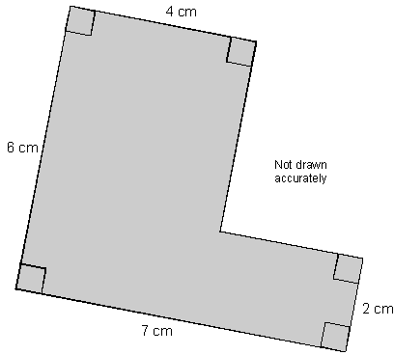

A student simplfies this fraction
7
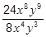
to 3x²y³
Are they correct? Explain your answer.

8
Expand and simplify 3(2x − 1) - 2(x − 3)

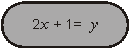
Look at this equation.
9

Use it to complete the equations below that involve both x and y

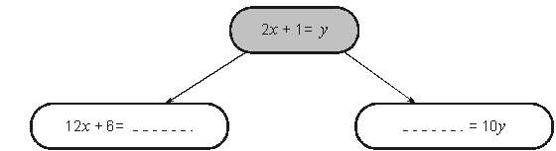

10
Solve 5x + 4 < 2x − 5

Display the solution on a number line.

11
A shop sells rings of different sizes.
The diagram shows the diameters of the different sizes.

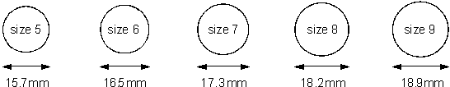

Rachel wants to buy a ring for her middle finger which has a circumference of 51mm. What size ring should she buy?

Show working to explain your answer.

Tick your answer
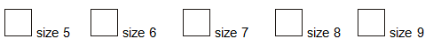

Asad is working out the area of a circle with radius 4
12
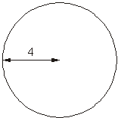

He writes:
Area = π × 8

Explain why Asad’s working is wrong.

2^{x} × 2^{2x} = 2¹⁸
13
Work out the value of 2^{x}

Show that the shaded area of this rectangle is 2(4x + 5)
14
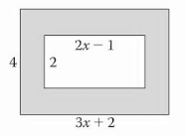

Look at this rectangle:
15

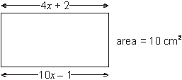

Form an equation in x
Use it to find the length and width of the rectangle

(a) w and x are whole numbers.
16

w > 40
x < 30

Work out the smallest possible value of w – x

(b) y and z are whole numbers.
y < 60
z ≤ 50

Work out the largest possible value of y + z

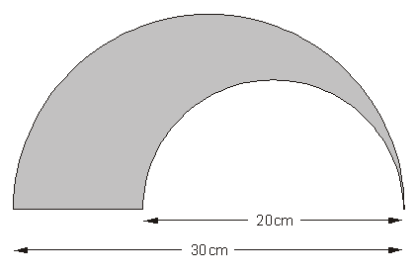

17
Calculate the perimeter of the shaded shape.

This shape is designed using 3 semi-circles.
18
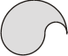
The radii of the semi-circles are 3a, 2a and a.
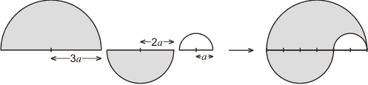
Find the area of each semi-circle, in terms of a and π, and show that the total area of the shape is 6πa².

